OHSGG Volunteer Guide Request Form

 |  |  |  |  |  |  |  |  | Applied Date
Information of the applicant
Mr./Ms. |  |  |  |  |  | Name |  |  |  |  | Age
Nationality |  |  |  |  |  | E-mail
Information of your party
First Name |  |  |  | Family Name |  |  |  |  | Mr./Ms. | Nationality |  | Age
Your  Itinerary | Arrive Hakone |  |  |  | Date & Time |  |  |  |  | From:
 | Leave Hakone |  |  |  | Date & Time |  |  |  |  | To:
 | Guide Request |  |  |  | Date & Time
 | Hotel Info. |  | Contact Information while in Japan (hotel, telephone, etc.)
Where do you want to visit and/or what do you like to do and see in Hakone and Odawara?
Additional notes, comments
Acceptance of OHSGG Guide Policy and COVID-19 Terms
✔ Yes, I have understood and accepted the OHSGG guide policy and COVID-19 terms.
Permission to post photos on the OHSGG Homepage and OHSGG Facebook page
(Homepage: http://www.ohsgg.com/index.html , Facebook: https://www.facebook.com/OdawaraHakoneGuide )
(Only photos are posted. No names and no other personal information are disclosed. Please refer to the above Facebook link for detail.)
✔ Accept to post photos. ✔ NOT accept. (Leave either one and delete the other.)
How did you find OHSGG? (Replace the □ mark at your answer to ✔ or ■.)
□ Web search, □ Link in other website, □ From your friends, □ Review in other website, □ Others
This information is ONLY used for the purpose of guide assignment by OHSGG. (2023.3.16)
*Guide policy and COVID-19 terms: See the following pages
Guide policy

(VOLUNTEER SERVICES)
1) OHSGG guides volunteer their services and do not hold any special licenses as professional tour guides.
2) OHSGG guides volunteer their time and talents to help guests have the best visit to the area possible with a customized itinerary and various preparations. In return, guests are expected to be considerate and respectful of their guide’s time by responding to communications in a timely fashion and following through with their commitment.

(EXPENSES)
Our services are provided free of charge. However, you are requested to pay the actual expenses for the OHSGG guide(s) as listed below:

1) Admission fees to enter temples, shrines, museums, etc. (Note: Most of the facilities in Hakone and Odawara allow the guide to enter free of charge.)
2) Transportation charges during the services.
3) Lunch. (Only when the tour involves lunch time.)
4) Travel expenses for the guide from his/her residence to the place where you meet the guide, and from the location where you end the tour to his/her residence. If you meet the guide at the Odawara station and end the tour at the same place, the estimated amount is from 0 yen to a little over 2,000 yen per day depending on where the assigned guide lives.
5) Other actual tour-related expenses, if any.

(OTHER CONDITIONS)
1) Neither OHSGG nor the guides accompanying you are responsible for any injuries, theft, lost and/or damages to possessions that may occur during the services.
2) OHSGG may provide more than 2 guides for a large group.
3) OHSGG does not provide the following tours:
-Night or overnight tours.
-Tours using private or rental cars.
-Tours for commercial purposes, including the tours arranged by travel agencies.
4) The service you request may not be provided if OHSGG cannot find the appropriate guide(s) and/or if you do not accept this guide policy.
5) The information provided in the application will be used by OHSGG only for the purpose of providing the requested guide services.
6) Photos of the guests that are taken during the tour may be used by OHSGG for the purpose of reporting OHSGG activities to OHSGG members and related organizations. OHSGG does not disclose any of these photos to public, such as OHSGG Facebook or OHSGG Website, without separate permission of the guests.

COVID-19 Terms

(GOOD HEALTH CONDITIONS)
1) Guests and guides are required to check the health condition in the morning of the tour date and to confirm if no one has flu-like symptoms such as fever, cough, sore throat, etc.
2) The planned guide service is only provided if all members of both guests and guides do not have any symptoms in the morning health check.

(TOUR CANCELATION AND ALTERNATE GUIDE)
1) If the assigned guide has some flu-like symptom before the tour date, the tour may be cancelled, or OHSGG may provide an alternate guide.
2) If a member with flu-like symptom exists in the guest group, the tour shall be cancelled.
3) In the case of cancellation, both sides must communicate each other as soon as possible.

(FACE MASK REQUIREMENT)
1) Throughout the tour, both guides and guests are required to follow the face mask guide-line provided by Ministry of Health, Labor, and Welfare of Japan. (“Mask Use Guidance Starting From 13 March 2023”.) This guide-line is not a law, but OHSGG uses this as the condition to provide the guide services.
2) Depending on the situation, you may be asked to put on a face mask. Please keep your mask being ready to use during the tour. Examples of the situations could be;
The public transportation that you take may be crowded.
Due to the facility’s policy, such as restaurants, museums, or other places may ask you to use a face mask.

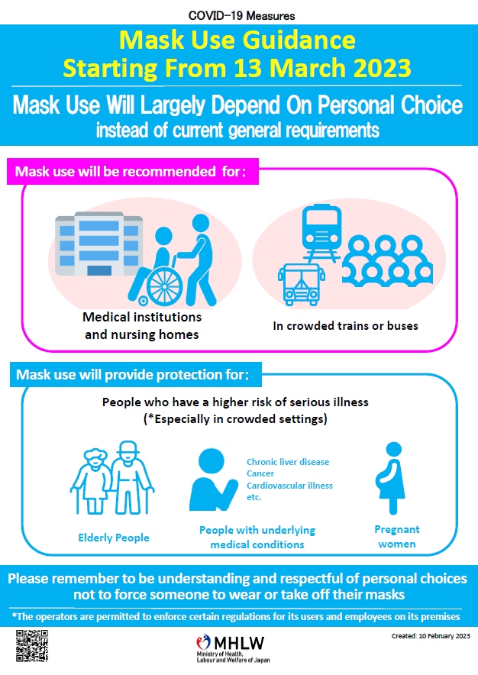

Source: Ministry of Health, Labor and Welfare of Japan
(https://www.mhlw.go.jp/stf/seisakunitsuite/bunya/0000164708_00079.html)

